Pronoun analysis summary

Count how many sentences have possession + people?

My mine belong belongs his --- people countries commonwealth

Possessive pronoun usage 🡪 slight decrease

“my” “mine”

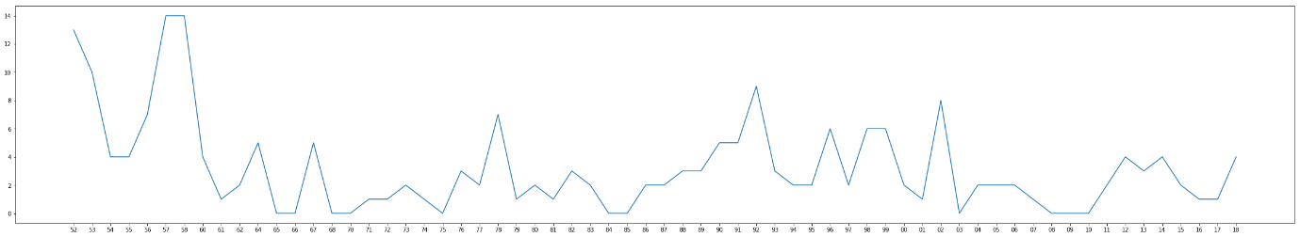

Partly to do with first-decade referring to people as “my people”:

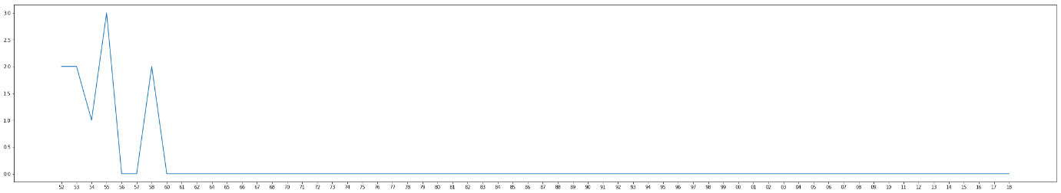

Language referring to commonwealth / empire / crown:

[this is more topical rather than pronoun analysis]

